I HEARD THE LORD SAY

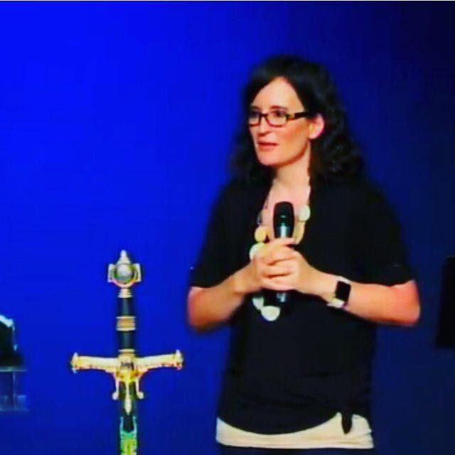
Lana Vawser
Brisbane, Australia
I HEARD THE LORD SAY "REMEMBER I SAID THIS WAS THE YEAR OF THE UNEXPECTED? HERE COME THE UNEXPECTED BLESSINGS"
This week I heard the Lord say "Remember I said this was the year of the unexpected? Here come the unexpected blessings"
The sense surrounded me that for MANY in 2019, they have been surrounded by the unexpected but in the NEGATIVE sense. There have been many who feel like they have been "sideswiped" by curve balls and unexpected attacks, situations and circumstances. Many have been in that place of crying out to the Lord "God, I can't take any more unexpected curve balls and hits. For many the word "unexpected" has become a negative word in 2019 that has produced a foreboding for the future.
When I heard the Lord say "Remember I said this was the year of the unexpected?" the sense surrounded me of the goodness, faithfulness and love of God. The divine surprises of a good father. As He spoke:
"Here come the unexpected blessings.."
I then heard His voice thunder in a strong decree...
"2019 THE YEAR OF MATTHEW 7:11"
"If you then, who are evil, know how to give good gifts to your children, how much more will your Father who is in heaven give good things to those who ask him!" (ESV)
"If you, imperfect as you are, know how to lovingly take care of your children and give them what’s best, how much more ready is your heavenly Father to give wonderful gifts to those who ask him?" (TPT)
The Lord showed me that there is a major turning of the tables taking place right now over many who have been knocked down and thrown around by continual unexpected circumstances, trials and attacks. The hand of the Father is turning the tables where there shall now be UNEXPECTED BLESSINGS that are being poured onto His people.
I heard the Lord say "I WILL MAKE UP AND MORE"
Not only will the Lord make up for the battles, the trials and what has been stolen, but He is going to make up for it and MORE. You will have more than you have asked for. You will carry more than you imagined. You will receive more than you have believed for.
The Lord continued to speak:
"Many of these unexpected blessings are coming in the most unexpected ways. Some of the most incredible blessings I am releasing to My people are going to flow in some of the most unexpected pathways and circumstances but the revealing of My love, nature, kindness, restoration and faithfulness will be astonishing."
The Lord showed me that because of weariness and the enemy using these unexpected circumstances and curve balls to weary God's people, many have stopped asking. The Lord is encouraging His people to ASK AGAIN! Do not allow disappointment or weariness to steal your voice. ASK again! Ask the Lord again and watch the blessings of the Lord unfold.
THESE UNEXPECTED BLESSINGS WILL SEE THE BREATH OF THE LORD BRING RADICAL TRANSFORMATION
The Lord showed me that these unexpected blessings will released into your life by the hand of the Lord will see His breath bring radical transformation.
Life, healing, peace, joy and hope will be breathed into you again by His Spirit. The fire of His love will overtake you with the revelation that He is a good Father and so much of this year has been full of tears in the pain and heartache, the despair of not understanding, but now you shall see tears of joy as you see that He is the Father of ABUNDANCE and RESTORATION. He is orchestrating unexpected blessings and the revealing of His plans that will truly unfold hearts desires within you and see them fulfilled but in greater ways than you have imagined. Where you have given up, He is going to blow you away with the demonstration of His goodness and revelation that His plans for you are grander than you could imagine. You will breathe again, you will step into a deep rest in Jesus like you have never known and you will be left never the same.
Some of the most unexpected blessings being brought to you through the most unexpected of circumstances will be the marker points of total life transformation.
But as it is written:
“Eye has not seen, nor ear heard, Nor have entered into the heart of man.The things which God has prepared for those who love Him.” (1 Corinthians 2:9-11 - NKJV)
This is why the Scriptures say:
"Things never discovered or heard of before, things beyond our ability to imagine, these are the many things God has in store for all his lovers." (1 Corinthians 2:9-11 - TPT)
"Hope deferred makes the heart sick, But desire fulfilled is a tree of life" - (Proverbs 13:12 - NASV)
"When hope’s dream seems to drag on and on, the delay can be depressing. But when at last your dream comes true, life’s sweetness will satisfy your soul." (Proverbs 13:12 - TPT)

