"How to Rebuild God's House and Family"

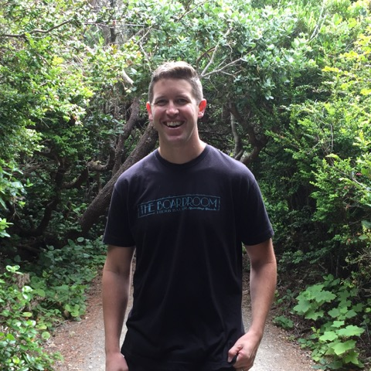

Joey LeTourneau, McCloud, CA
July 29th, 2019
From California to Israel
When my family and I moved back to California in 2014, it was with an eye towards Israel and some of our long-term calling there. Shortly after moving back the Lord showed us why He called us to move back. He offered us a vision of a "bridge" that spanned between California and Israel.
God has continued to show us the vision of this bridge. Not a literal bridge, this "bridge" is meant to be constructed uniquely, lifting people up higher. It's intended to be made up of "refuge-like" properties and lands that God's sons and daughters have been in and are now taking for the Kingdom. They are hot spots on a map, strategically placed, set apart, and are preparation grounds for many that God is raising up between California and Israel—with the intention of rebuilding God's family.
We personally have been contending for such a bridge over the years but it was not until the last number of months we felt a release from the Lord to pursue and possess the vision and to help others by faith do the same.

Angelo and the Timely Gift
"In My Father's house are many mansions; if it were not so, I would have told you. I go to prepare a place for you." (John 14:2)
This passage was highlighted to me after I had a special encounter. I had the encounter the night after my family and I committed to a specific part the journey of "rebuilding God's house and family." Early in the morning, in one of the most vivid dreams I've ever had, I was awakened to a knock at our door. When I answered, there was an Italian looking man approximately in his sixties who said, "My name is Angelo, I'm your angel and this is one of the happiest days of my life." He then handed me a lavender, ring-sized gift box with a white ribbon before he disappeared. I carefully opened the box and wondered if it was a ring, or what was possibly in such a package. I unfolded the white tissue paper and discovered a single, silver house key.
Now, you have to understand that for us, personally, we are waiting for the right house and property ourselves as we contend to position and align with where the Father wants us to build with Him. So, a house key would be an awesome, personal gift and breakthrough! However, I knew in the dream that Angelo's very intentional happiness in presenting this key wasn't just for our personal breakthrough, but even more for what was being released for this time and the re-building of God's big picture house and family.
A Refuge and a City on a Hill
"In the fear of the Lord is strong confidence, and His children will have a place of refuge." (Proverbs 14:2)
"You are the light of the world. A city that is set on a hill cannot be hidden." (Matthew 5:14)
It can sound contradictory to imagine a place that is a refuge, like the shadow of His wings, and yet also for the same place to be a city on a hill that should not be hidden. But we live in a Kingdom that holds these types of beautiful truths in tension with one another. God is raising up existing and new lands that will powerfully embody both at the same time.
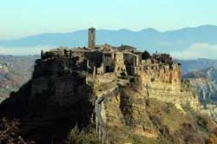
These places of refuge, lands of resources, and "hot spots" of God's family are places where the Body of Christ will go to be re-calibrated and refreshed. They are off the beaten path and will allow Believers to "come up higher" out of the task they are engaged with, re-calibrate, and go back into their calling IN the world with renewed vigor, alignment, and with peace and purpose to give. (Photo via Free Great Photo)
At the same time these places of refuge will also serve as a "City on a Hill," where weary wanderers of the world will find living water, the bread of life, and the contrasting light they've been searching for. As Jesus often did, there is something powerful to going away consistently to re-calibrate—and not just in the midst of daily rigors or taking a summit once or twice a year. These places will be needed for God's sons and daughters to "get above the cloud line" more often.
These places will be like watering holes and apostolic hubs that live and walk in a Acts 4-like community atmosphere—coming and going to and from all aspects of life and coming from all over the world. They are not program centric but people and presence focused. Watch as these sort of places and relationships come together. Many are already stepping into these lands, many have dreamt of such, and many others will soon join.

How Do We Possess and Build These Lands?
"'This is the word of the Lord to Zerubbabel: Not by might, nor by power, but by My Spirit,' says the Lord of hosts."(Zechariah 4:6)
The notes in the New Spirit-Filled Life Bible state this about Zerubbabel as a re-builder of God's house: "Zerubbabel is ultimately responsible for rebuilding the temple, but he is forbidden to trust the resources of man to accomplish this task. So today God's holy temple, the Church, must be built and sustained, not by wealth, by members, by virtue, nor by sheer strength, but 'by My Spirit.'"
We are not apprehending these places and lands by human means, wealth or strength, but by the authority of His Spirit. So don't be discouraged if you don't seem to have the means yet, just keep following Him with faith and obedience and step into the land that He is or will show you.
The process you have endured and persevered through these past seasons may have left you feeling depleted in the natural of tangible resources for building, but God has seasoned and strengthened you with the same kinds of intangible resources that Zerubbabel was charged with trusting in and building through. These intangible resources come alive through the process we've each just endured. The challenging circumstances you are emerging from have actually profited you the very resources you would need to take ground and build up His family in this present time.
The Power of God's Delight, His Favor and His Countenance
"If the Lord delights in us, then He will bring us into this land and give it to us, a land which flows with milk and honey."(Numbers 14:8)
Recently we were driving into the territory God had told us to contend for, asking Him to show us His strategies to possess the land. During our drive the Lord brought this passage of Numbers 14:8 to heart and we started to declare it as we drove, "If the Lord delights in us, then He will bring us into this land and give it to us."
Moments later, a close friend messaged me not knowing the promise God had given us to declare that day. His message said, "Bro, the Lord is delighting in you!" The only "if" written in this promise is the Lord's delight, and God wants to remind us how delighted He is when we step out in faith with Him. The delight of the Lord paves the way to promises realized. So as you look at the land before you which He is speaking about, remember His delight over you is one of your most precious and powerful weapons.
"For they did not gain possession of the land by their own sword nor did their own arm save them; but it was Your right hand, Your arm, and the light of Your countenance, because You favored them." (Psalm 44:3)

The Key of David
"The key of the house of David I will lay on His shoulder; so He shall open, and no one shall shut; and He shall shut, and no one shall open." (Isaiah 22:22)
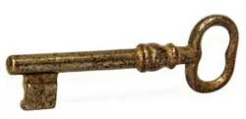
"First love" intimacy is how we utilize this key and where our authority dwells to unlock the doors and gates to these lands and see the Father establish them. The key of David isn't a form of contending for such lands that requires striving; rather it is the simple yet powerful authority where we reach toward the lock by reaching through God's heart, and during the process He cuts that key to match the access point. Entry is granted as now the right key has entered its matching door. Intimacy is the key to apprehending our land.(Photo via Pixabay)
A Testimony of Simple Faith - "We Ask You God for a House"
Our family has gotten to be part of a number of miraculous testimonies with houses and lands over the years, and to be honest we are even contending for such now. But one testimony I've grown up hearing has always been highlighted. My mom and her siblings were young, their dad was about to pass away within days after being sick for eleven years, and my grandma was working tirelessly on multiple fronts. They had to be out of their house quickly and needed God to provide.
One day, needing to search for a home but without time or money to do so, my grandma pulled over with kids in the car and simply said to the Lord, "You know I don't have time or money to find this new house, but You have promised to provide for us and we ask You God for a house." That very week the neighbor with a big house on a large lot across the street knocked on the door and said, "I was thinking and realized I don't need my house anymore, and you do. I want to give it to you and we can work out some form of compensation later down the line." Thereafter, the family and many friends literally formed something of an "assembly line" passing item after item across the street to move into their new home!
That house became both a refuge and a beacon of light over the years for God's family. Long-term and short-term, it housed leaders, missionaries, those going through difficult seasons, as well as family and friends. The house was a miracle and then many more miracles happened there. It wasn't gained by man's ways or resources, but by simple faith in a good Father who loves to set up places for His family to be loved and empowered.
May you make this testimony your own and see it multiplied unto the family of God around you!

