September 16, 2017

"Australia Shall Lead in the Healing Of Nations"
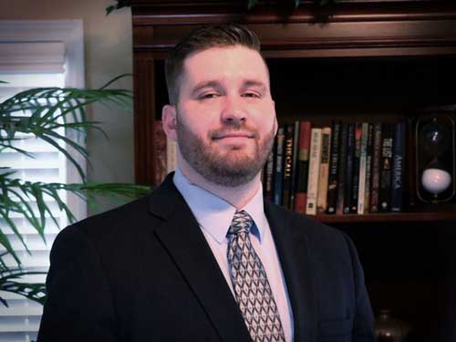
by Stephen Powell, Fort Mill, SC, USA
The word of the Lord came to me saying, "Prophesy My son to the nation of Australia, for now is her hour to arise and shine as a global light for good, for shelter, and for the healing of nations. For out of the south of her land shall arise a mighty fire of healing revival which shall not be quenched as it travels north through the land. Lo, it has been resisted not once, but twice in this respect, but what I am bringing is an Acts 6 anointing which cannot be resisted, for My servants shall arise and speak forth the wisdom of God in the south to the north. They shall declare it as a trumpet to the north, and the north will have to listen and heed, because I, the Lord, will back these words coming from the southern prophets. They are My oracles, My mouth pieces, they will be My Moses and Aaron to the nation, for they will speak and prophesy and I, the Lord, will perform through their words. They shall herald the trumpet of God in Australia for a new day, a resetting of the clock of Heaven in this land."
Healing for the Nations
I see the Lord balancing this nation on a dial...as a plumb-line message emerges to turn the nation back into its proper alignment before God. I see the nation turning and burning with fire, even an unquenchable fire which shall come from the south, for out of this land will come healing for the nations.
"People have left, people will leave, and these are the leaves for the healing of the nations. It began here with My servant Alexander Dowie, and when he left and was released as that wind from out of the south, there came forth the anointing for the healing of the nations, and it will yet cycle back around from this place again, an anointing for the healing of the nations. It shall shoot into Asia, and it shall burn with a fire, and this fire shall rise in prophets and healers as they go forth, and they shall heal lands with fire to the north; but they shall also prophesy against the powers of the evil one that has ruled over lands to the north for many generations.
"But behold, I, the Lord, have declared that it is time to address the iniquity to the north and address the spirit powers behind it. For there is a people whom I will have for My Bride, cleansed and spotless and purified from these roots of deception, the demonic filthiness going back generations which is in these lands like latent webs entangling its people in iniquity. But behold I shall burn through these lands like unquenchable fires, and behold they will not be able to hold back this force from Heaven which I will release out of southern Australia, for it is healing for the nations, cleansing for the nation.
"I will cause crooked pathways to be straightened, even across the sea, for you will see that I, the Lord, visit the distant islands, and stretch forth My hand with authority, and in one day I change what you have not been able to change in all your prior seasons of toiling. You will see that I, the Lord, will change it even in a day. For you have endured fishing all night and have caught nothing in these waters for all your toiling. But behold I am releasing My word for strategic apostolic harvesting, for you, Australia, shall go out with My harvesting angels.
"You shall be My sent ones, and as sent ones you will go into places at strategic times, and in those times I will open to you the floodgates of Heaven to overwhelm the enemy in these lands. It will be My suddenly which I give to you, and it will be a blitz, a suddenly thrust upon the enemy, which he will not be able to scramble quick enough to counter effectively. Behold, I have determined harvest in these lands, and these harvesting winds will flow out of southern Australia. I am the Lord.
"Leaves for the healing of the nations, it's written in your land from the beginning. You are a balm, a people of healing for nations. You will be a part of healing Korea, hear My words. You will be a part of healing Europe, hear My words. You will be a part of healing America, hear My words. I will send soldiers out of Australia, armed for war, and they shall go into places which I, the Lord, will open up for them to go. They shall be a part of a coalition to fight evil in this day, and they shall be My soldiers on the frontlines of a conflict which I intend to bring healing through," says the Lord.
I Will Make You Famous in Your Day
The Lord says, "There is a healing angel to the north with a large sickle and he is waiting for the movement to join him from the south, and from the south will come the thrust which has been needed," says the Lord. "I have cultivated something in the south...a secret weapon for the nations.
"Get ready Australia, for I will make you famous in your day, Adelaide...you will be made famous in your day. It will be like the word which says that the Lord's name was made famous through Judea, Samaria, and all those lands as the blind eyes were opened, as the cripples walked, as those with epilepsy were delivered, and as the maimed grew limbs back in the glory.
"I have storehouses of Heaven full of creative supply for the working of miracles in this new day, a day of healing, a day of wonders, a day to capture the attention of all people groups, for from this place I will bring glory to the name of Jesus, even with great power and with great fame," says the Lord.
"Be prepared to leave, be prepared to lead, for these are the leaves of healing for the nations. Your preparation is almost complete. You shall be released in this day, you shall drop down the heavens over darkness and Hell itself in My world, and you shall be a stream in dry places. You shall be that healing I've purposed you to be."

