I AM BRINGING YOU BACK FROM THE BRINK
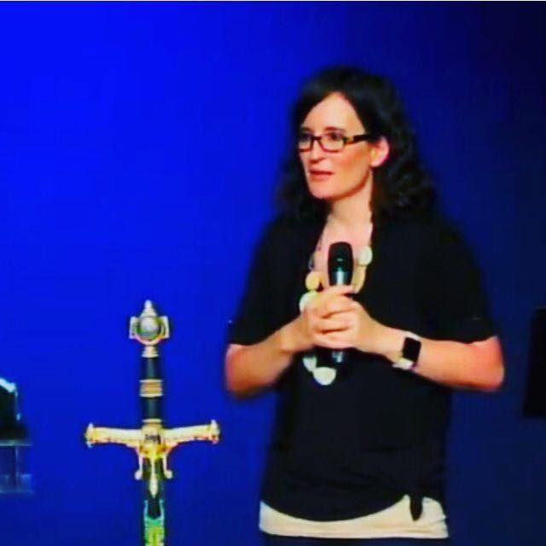
Lana Vawser
July 2019
Last week I heard the Lord say over many in the body of Christ "I AM BRINGING YOU BACK FROM THE BRINK"
The Lord showed me so many in the body of Christ who have been "at the brink" in so many different ways and everything is screaming at them that they are going to go OVER THE EDGE but the Lord wants you to know that you are NOT going to go over the brink.
The Lord is with you, He is holding you and His mighty hand is going to save you. His mighty hand of deliverance is going to come upon you. You may be feeling like you are drowning but the mighty hand of God is going to save you.
I had a dream recently and saw someone in deep waters and they were drowning. When they came to their very last breath in that place of drowning, death was staring them in the face, SUDDENLY a HUGE hand came out of the water and saved them.
When the person was pulled out of the water there was an incredible sense of the power of worship that filled the atmosphere. I woke with the strongest sense for those that feel like you are on the brink and you are drowning, you are scared, terrified and don't know how to get out, WORSHIP! Don't move from the place of praise and worship! The mighty hand of God is going to deliver you.
Many of you have come to the end of yourselves, feeling more broken than you ever have. You have come to the end of your own strength. You can't see your way out, but GOD can and NOW He is going to step in and He is going to deliver you. God is going to show Himself SO strong on your behalf.
"Our God is a mighty God who saves us over and over!
For the Lord, Yahweh, rescues us
from the ways of death many times." - Psalm 68:20 (TPT)
“The angel of the Lord encamps all around those who fear Him, And delivers them” Psalm 34:7 (TPT)

FROM THE BRINK TO BRIGHT SUNNY DAYS
As I sat with the Lord and listened to His heart I heard the words "FROM THE BRINK TO BRIGHT SUNNY DAYS"
I had a vision and saw the mighty hand of God delivering His people from the brink and then Jesus grabbing their hands and walking them into BRIGHT SUNNY DAYS.
Right now, for many, on the brink it looks dark, it looks like the opposite to a bright sunny day... but I want to encourage you with this..
BUT GOD!!!!!
The Lord spoke to me at the beginning of this year and told me that He is reintroducing the body of Christ to His power. You are about to be reintroduced to the power of God, the power in the name of Jesus, the person of Jesus Christ, the power of His mighty hand to save and deliver you from the brink that you find yourself standing on.
I saw many in such distress on the brink, in such anxiety crying out "I don't know what to do about this, I don't know how to get free, I don't know what to do to step into the breakthrough" and I heard His whisper "Do not fret, be at peace! I have gone before thee"
He has gone before you, He's prepared the way, He, JESUS is the answer and HE is going to deliver you and He is going to deliver many of you and your families.
"I AM REMOVING THE ROOTS AND RENEWING YOUR YOUTH"
I had a vision of many in the body of Christ that are dealing with issues of the heart and these issues of the heart have been suffocating, they have been scary to see, and again that sense surrounded of not knowing how to deal with what's going on inside. So many cries "Lord, what's going on inside of me?"
I heard the Lord say "I AM REMOVING THE ROOTS AND RENEWING YOUR YOUTH"
The sense surrounded me strongly of the invitation to trust Jesus. To trust that the Lord is working, He isn't just standing on the sidelines waiting for you to work out how to "fix this" He is working deeply and His power and His love is going to REMOVE those roots out of your heart. HIS hand. Be still, in the rest of the heart and continue to invite the Holy Spirit to do whatever He needs to do to remove the roots. He is not ignoring you. He hasn't forgotten you. He is bringing things UP so they can COME OUT. He is turning the bitter places to sweet ( Exodus 15:19-27)
The Lord showed me these roots in heart, roots of bitterness, trauma, pain, fear, heartache have stolen and robbed so much from His people. They have kept them caged, they have stolen their youth as they have carried these weights for so long, but the Lord's love, the wave of His love is crashing over you. Not just one wave, but wave, after wave, after wave and those roots are being removed and He is renewing your youth. Many of you who even feel like the pain and trauma and weariness is written "all over your face", as repentance takes place, as alignment happens, as deep dealing, miraculous shifts and miracles of transformation of the heart take place, I heard the Lord say "IT WILL SHOW ALL OVER YOUR FACE". Many of you will see your face SHINING with the love, hope, joy and glory of the Lord. There will be a NOTICEABLE difference in your face revealing what the Lord has done INSIDE you.
But those who wait on the Lord
Shall renew their strength;
They shall mount up with wings like eagles,
They shall run and not be weary,
They shall walk and not faint. (Isaiah 40:31 NKJV)
THIS IS THE FINAL STRAW
I heard many crying out "Lord this is the FINAL STRAW! I can't take anymore" and I saw Jesus hold their hand and He spoke "Yes, My Beloved, indeed it is the final straw"
I was a little perplexed as to what He meant and then all of a sudden the understanding came to me.
The triggers of the heart, the woundings of the heart that the enemy has used over and over and over again to bring God's people into this continual cycle of hopelessness, anger, discouragement, despair, heaviness - that very thing in the heart the enemy has been using that keeps sending God's people to "the edge" in so many ways, the hand of God and the love of Jesus is BREAKING that trigger point and healing the heart once and for all.
This is the BREAKER OF BREAKERS! This is the breakthrough that is going to shift and change everything to end the cycles that have caged you and contained you for so long.
THIS is the miraculous breakthrough that will shift you from the place once and for all of feeling like you're 'dying' to 'thriving'. Truly stepping further into the abundant life that is yours in Christ (John 10:10)
I could hear the Lord decreeing "THIS IS THE ONCE AND FOR ALL. I AM SETTLING THESE ISSUES ONCE AND FOR ALL"
VICTORY! VICTORY! VICTORY!
The victory of Christ is manifesting in your life. The victory that is yours in Christ. Every chain, every cycle, everything will bow to the name of Jesus!!!!
"This “realm of death” describes our former state, for we were held in sin’s grasp. But now, we’ve been resurrected out of that “realm of death” never to return, for we are forever alive and forgiven of all our sins!
14 He canceled out every legal violation we had on our record and the old arrest warrant that stood to indict us. He erased it all—our sins, our stained soul—he deleted it all and they cannot be retrieved! Everything we once were in Adam has been placed onto his cross and nailed permanently there as a public display of cancellation.
15 Then Jesus made a public spectacle of all the powers and principalities of darkness, stripping away from them every weapon and all their spiritual authority and power to accuse us. And by the power of the cross, Jesus led them around as prisoners in a procession of triumph. He was not their prisoner; they were his!" - Colossians 2:13-15 (The Passion Translation)

